Structural Sustainability Report
Template for use by structural engineers
V1 – 4 May 2022

The Institution of Structural Engineers
Contents
Executive summary 3
1. Introduction 4
1.1 The United Nations Sustainable Development Goals 4
1.2 The climate emergency 5
1.3 Whole life carbon 5
1.4 Net zero carbon 7
1.5 Circular economy 8
1.6 Biodiversity 9
1.7 Client ambitions and policy requirements 9
2. The Brief 10
2.1 Maximising reuse opportunities 10
2.2 Enabling low-carbon design 12
2.2.1 Materiality 13
2.2.2 Carbon targets 14
2.3 Whole-life considerations 14
2.3.1 Flexibility vs adaptability 15
2.3.2 Durability and circularity 16
2.3.3 Resilience to climate change 17
2.4 Innovation 18
2.5 Wider sustainability considerations 18
3. Carbon Calculations 19
3.1 Carbon Targets 19
3.2 Calculation methodology 19
3.2.1 Accuracy and uncertainty 19
3.2.2 Scope 20
3.2.3 Assumptions 21
3.3 Carbon results 22
4. Design approach 23
4.1 Configuration 24
4.2 Structural solutions 24
4.3 Design criteria 25
4.3.1 Strength (loading requirements) 25
4.3.2 Serviceability 26
4.4 Optimisation of sizes 26
4.5 Supporting other disciplines 27
5. Construction approach 28
5.1 Specification 28
5.2 Procurement 29
5.3 Enabling in-use and end-of-life benefits 29

Executive summary

- Introduction
This report presents the key considerations and actions taken by the structural engineers relating to sustainability on the project, with a focus on achieving a low embodied carbon structure. As the structure is typically responsible for two thirds of the embodied carbon footprint of a building, a low-carbon structure is key to a low-carbon building.
This introduction gives an overview of the sustainability issues facing the built environment, and their relevance to projects such as this.
The next section of the report then highlights the importance of establishing an informed brief; which is a key enabler of a low carbon solution, embedding sustainability at the heart of the decision-making process.
To maximise transparency and allow verification of industry alignment, the carbon calculation methodology is then outlined, and the carbon targets and results presented.
The latter part of the report focuses on the design and construction approach taken to achieve the desired low carbon outcomes.
Other reports by the rest of the design team include other sustainability outcomes related to the project, that the structural engineer may have had input towards.
  - The United Nations Sustainable Development Goals
The United Nations (UN) Sustainable Development Goals (SDGs) are 17 interlinked global goals that exist to ensure that countries are coordinated when mobilising efforts to end poverty, fight inequality and tackle climate change – a "blueprint to achieve a better and more sustainable future for all". The UN SDGs came into force in 2016, and are adopted and recognised by all 193 UN member countries around the world.

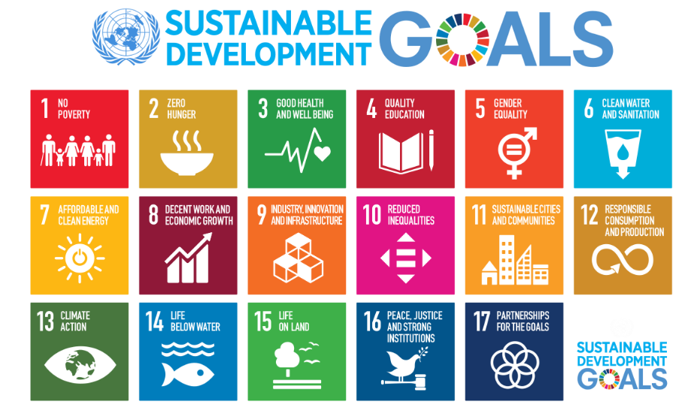
Figure 1 - UNSDGs

This report focuses primarily on SDGs 9 (Industry, Innovation and Infrastructure), 11 (Sustainable Cities and Communities),12 (Responsible Consumption) and 13 (Climate Action). These are the goals which through the design and construction phases of a project, the structural engineers have the most significant impact on.
However, the importance of all 17 goals must be stressed, and wider sustainability considerations addressed throughout the project. In some cases, increased carbon emissions may be well justified by the significant contributions to other SDGs, and this should be respected.
  - The climate emergency
In May 2019, the UK Parliament passed a motion declaring a climate emergency. Globally, buildings and construction account for nearly 40% of energy-related carbon dioxide (CO₂) emissions.
However, construction of the built environment is also necessary to improve and protect lives. Therefore those responsible for funding, designing, building and operating this built environment must ensure that emissions are minimised, whilst also maximising the societal benefits of the built environment.
Structural engineers have recognised this challenge, with many practices joining ours in declaring a climate and biodiversity emergency as part of the global Built Environment Declares movement.
  - Whole life carbon
The impact that buildings and construction have on climate is a result of greenhouse gas emissions which occur at several stages of a building’s life cycle. These life-cycle stages and modules are demonstrated in Figure 3.

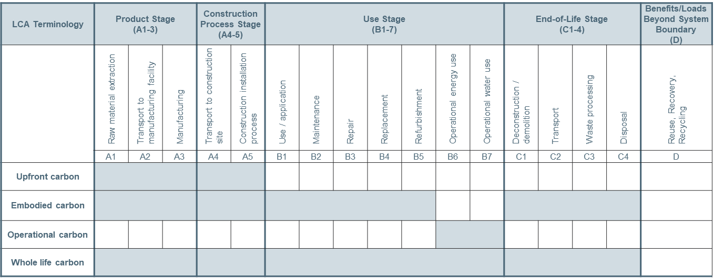
Figure 2 – Lifecycle modules in a whole life carbon assessment

As shown, the lifecycle is broken down into four key stages (product, construction, use, and end of life) that cover emissions during the life cycle of the building.
These stages are broken down into modules, which are classified as either embodied carbon (A1-A5, B1-B5, C1-C4) or operational carbon (B6,B7) emissions, as shown in Figure 4. An additional module (module D) represents emissions or savings beyond the life cycle of the building.
The focus of this report will be on embodied carbon emissions, as this is what structural design predominantly impacts.

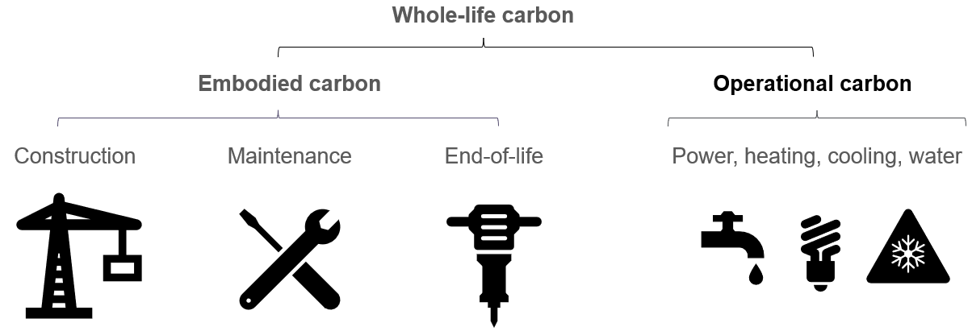
Figure 3: Whole life carbon is the sum of all embodied carbon and operational carbon emissions for an asset

When considering the breakdown of whole life carbon of a building, the proportions of embodied and operational carbon vary, and are changing over time.
Operational carbon emissions are mainly dependent on the power network and the use of gas – so grid decarbonisation has significantly reduced operational carbon emissions over recent years, and will continue to do so, along with moving away from gas boilers and taking steps to reduce energy demand (e.g. insulation, passive design, LED lighting).
Contrastingly, embodied carbon emissions are mainly dependent on fossil fuel based industrial processes such as mining, refinement and heavy transportation, as well as CO₂ emitting chemical reactions such as the production of Ordinary Portland cement. In fact, only 15% of embodied carbon emissions are estimated to be caused by electricity demand, so grid decarbonisation has a much less significant impact on these emissions.
As such, embodied carbon is responsible for an increasing proportion of whole life carbon emissions of buildings – highlighting the importance of reducing embodied carbon (refer to Figure 5).

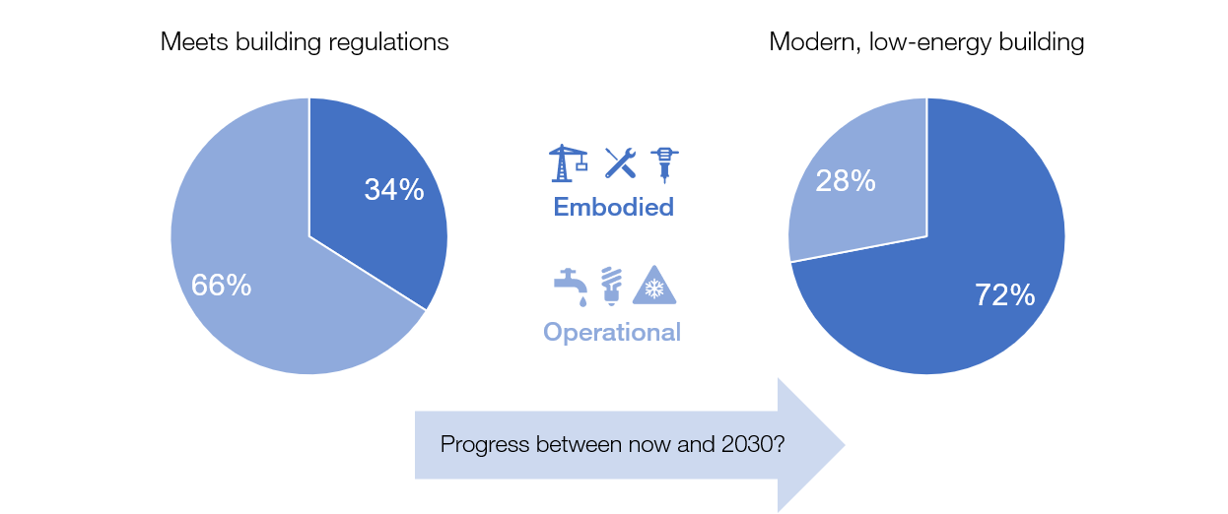
Figure 4: During its lifetime, a modern low-energy building can emit more embodied carbon than operational

  - Net zero carbon
A net-zero-carbon asset is one where the asset-related GHG emissions, both operational and embodied, over its lifecycle (all modules shown in Figure 3), are minimised to meet local carbon targets, and are then offset in their entirety.
In the short term, the use of offsets can enable net zero at a local scale (e.g. on a project), with greenhouse gas emissions reductions or removals being used to ‘balance’ the emissions due to the asset being offset.
However, the offsetting of all global emissions is not currently possible due to scale, and therefore significant reductions of emissions are required to achieve net zero globally. For more information on offsetting refer to ‘A short guide to carbon offsetting’
Further, the timescale at which we achieve net zero carbon is vital, as the cumulative emissions between now and then will directly impact the peak warming the climate will experience. The IPCC have estimated how much more carbon our atmosphere can hold before it is likely that 1.5°C of global warming will be exceeded – and from this have specified that global emissions must halve by 2030, and drop to net zero by 2050
As a result of these drivers, there is a need to rapidly minimise project emissions, following the hierarchy in Figure 5 which is the focus of this report.

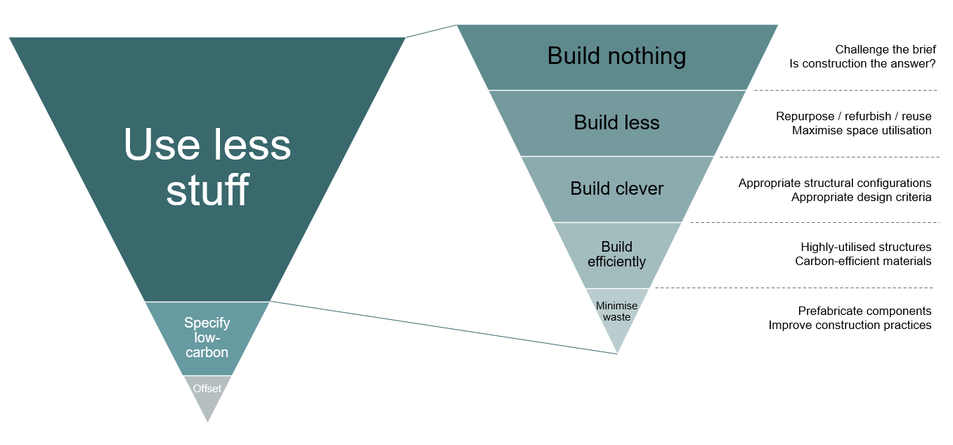
Figure 5: The IStructE hierarchy of net zero design (adapted from PAS 2080)

  - Circular economy
A circular economy is one where resources are kept in use for as long as possible, extracting the maximum value from them while in use, and recovering and regenerating them at the end of their service life – thus reducing demand for new material production which is energy intensive and environmentally damaging.

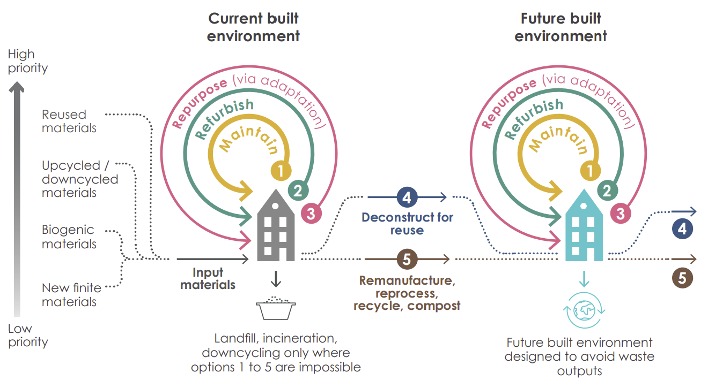
Figure 6: Material flows in a circular economy - both today and in the future

It is recognised that globally, a circular economy must replace the traditional linear economy in which we extract, use and waste material at end of life.
Circular economy thinking can be used to minimise carbon and energy emissions today by reusing existing materials rather than extracting and using new raw materials. Currently, the construction industry typically relies on new structural materials and the uptake of re-used materials is low – a significant area of improvement for all projects to address.
As well as re-using materials now, we must also consider how today’s materials can feed into a circular economy in the future. Designing buildings to be deconstructed is one way in which the value of today’s materials can be maximised in the future, and increases the value of assets.
It is worth noting that it can be hard to balance today’s carbon emissions with circular economy principles. Some design options that maximise future value will increase today’s emissions (e.g. through a less efficient design). It is important to carefully consider the building’s use and design life when designing to optimise the balance between emissions and circular economy principles.

  - Biodiversity
The Climate Emergency and Biodiversity Crisis are interlinked. Climate breakdown is a driver of biodiversity loss, which in turn increases the rate at which our climate breaks down. It is vital therefore that biodiversity is tackled alongside carbon emissions.
Every building project has a wider environmental impact, both on and beyond the site. A project’s impact on the biodiversity is often significant, and the design should minimise biodiversity loss, or better still result in a biodiversity net gain.
Whilst the design of the structure may not always offer chances to enhance biodiversity on a project, there are many opportunities to reduce biodiversity loss both on-site and beyond (e.g. at the sourcing locations of materials used). Biodiversity loss can be minimised through reusing existing buildings/materials, responsibly sourcing of new materials, and ensuring that parties such as the ecologist and contractor are collaborating with the structural design team.
  - Client ambitions and policy requirements
This project should meet your sustainability ambitions in line with your Corporate Social Responsibility Statements and wider commitments (e.g. Science Based Targets initiative) made to align with national legislation for achieving net zero.
The project must also meet requirements dictated by local and national planning policy and regulation and be resilient to future changes which may impact on planning approval as well as reputational impacts.
The following provides a summary of the requirements agreed for the Project to meet these ambitions and requirements.

- The Brief
The project brief is more than just a set of client requirements. It sets the outcomes that the design must satisfy, and the principles to which design and construction must be aligned. This has a significant impact on the carbon intensity of the design, as it governs the material usage that is required.
The underlying principle to achieving the lowest carbon solutions is to satisfy the Client’s desired outcomes with less material, with the most significant carbon reduction potential in earlier design stages where key decisions (such as choosing to refurbish rather than to demolish and rebuild) will have the largest carbon saving potential.
Figure 6 shows how early decisions can result in the highest reduction in carbon. This aligns with the right-hand triangle in Figure 5, which highlights how strategic decisions such as reuse and size of building (taken at planning stage) will lead to more significant carbon savings than detailed decisions such as designing and constructing efficiently.
This section therefore outlines the key decisions made on this project to develop a brief that enables a low carbon solution.

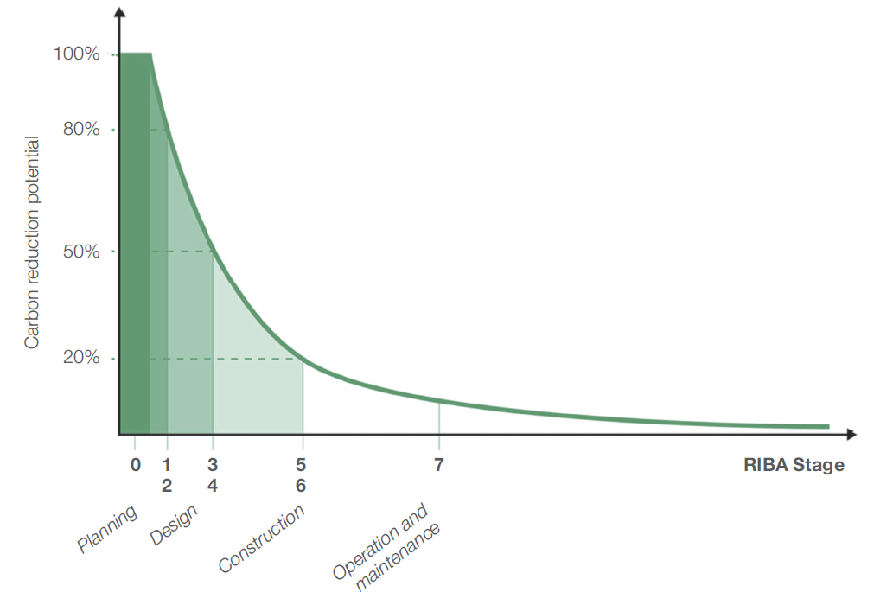
Figure 7: The highest carbon reduction potential comes with the earliest decisions
  - Maximising reuse opportunities
Reusing existing materials is the best way to reduce embodied carbon (second only to doing no construction at all, refer Figure 5), as the creation of new materials and products is energy- and carbon-intensive. This can range from reusing an entire building to reusing components, with benefits maximised by reusing the largest ‘pieces’ possible (i.e. whole building reuse saves more carbon than dismantling).
Actions taken on this project to maximise the reuse of existing materials to minimise new material demand have been provided below, as well as the next steps required to maximise the reuse potential and further opportunities to investigate.

Objectives and Actions taken:

Next Steps and Opportunities:

  - Enabling low-carbon design
To maximise the opportunities for low carbon design, the brief has been interrogated to find opportunities to reduce material use whilst still meeting the outcomes of the brief.
Table 1 outlines the key considerations for achieving a low-carbon design (further information and detail is provided in Section 4):
Table 1 - Key Considerations of the Brief which Impact the Low Carbon Potential of the Design
Consideration | Commentary
1. Structural Grid  (See Figure 8) | Permitting reductions in allowable column spacing in the brief will have minor impacts on circulation and flexibility of space use, but will enable the most significant carbon reductions in a design – through understanding the carbon impacts of grid choices we hope that reductions in grid spacing can be considered
2. Basements | Reducing and eliminating basement demand may be achieved though relocating plant and utilising public infrastructure and active travel. Omission of basements will save significant amounts of carbon due to the carbon intensity of basements compared to above ground space and through understanding these impacts we hope that other solutions can be adopted
3. Floor Heights | Although not possible for all buildings, small increases in total height will increase structural zone allowances, enabling more efficient solutions and saving carbon. Through highlighting the carbon impacts of different options, we aim to establish an allowance that minimises carbon whilst meeting planning and spatial requirements of the brief.
4. Column Alignment | Permitting columns to run through to foundations (avoid transfer structures) may reduce open space and flexibility at lower levels but saves significant carbon emissions (and cost). Working collaboratively with the architecture team, we will look to present options to minimise transfer structure requirements with minimal impacts on layout flexibility.
5. Cantilevers | Reducing the need for cantilevers such as overhangs and non-enclosed balconies may impact on aesthetics and total GIA but will reduce carbon emissions. Again, we aim to provide solutions than minimise cantilevering structures whilst delivering aesthetic and spatial desirables.
6. Loading and Serviceability Requirements | Ensuring loading and serviceability requirements are to codes ‘and no more’ will save carbon associated with overly conservative allowances provided unnecessarily in some guidance documents . We will use our technical expertise to advice on requirements that are onerous and add carbon to the solution and ensure these are omitted where possible.
7. Materiality | The materials used on the Project will have a significant impact on carbon emissions. It is imperative that we utilise our available materials by using the right materials, for the right purposes, in the right place.
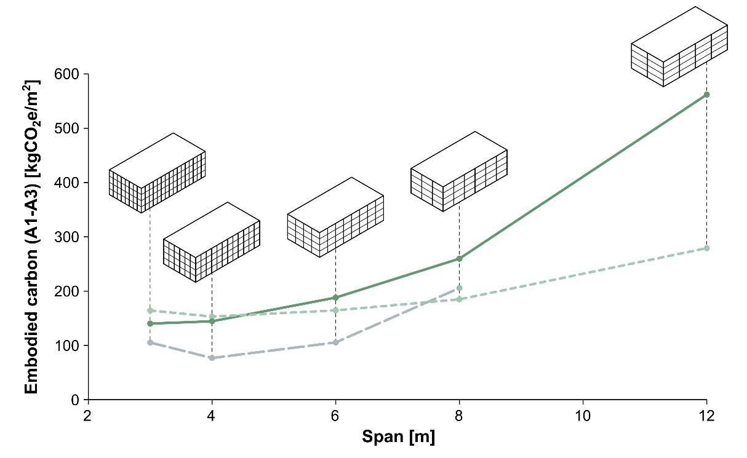
Figure 8 - The carbon impact of grids – typical values for different grid spans and construction types (not project-specific)

The carbon impacts of options relating to the criteria above have been provided below, along with outcomes agreed based on these considerations. Next steps and opportunities to develop these principles though the design phase are outlined.
The design approach is further detailed in Section 4 based on the principles outlined below.

Results and recommendations from high-level carbon studies on key brief considerations:

Next Steps and Opportunities: (note that this links into Section 4 as the design progresses)
    - Materiality
Whilst Figure 5 demonstrates that the biggest opportunity to save carbon comes through reductions in the amount of material used, the choice of material and the structural configuration are linked. For example, shortening the distance between columns could unlock the use of a weaker but lower-carbon material, leading to additional carbon reductions on top of those presented from shortening the grid.
Most buildings in the UK utilise brick and block (housing) or steel and concrete (everything else), however it is possible to build in a far broader range of materials than this – traditional lumber, engineered timber (such as glulam and CLT), earth, straw bale, stone, and so on. It is important that a full pallet of materials is considered, as often the most sustainable solution will also be that which is most suited to the building’s intended use and brief requirements. Material options considered to date, along with possible next steps, are provided below.

Material considerations so far:

Next Steps and Opportunities:
    - Carbon targets
Carbon targets have been set for this project based on best practice industry guidance provided by the RIBA, LETI and the IStructE. These targets are 1.5°C-aligned, aiming to halve typical industry emissions by 2030 in accordance with Section 1.4.
The targets for this project are provided below, along with a description of decisions made to derive the structural target from within the overall project target:

  - Whole-life considerations
“Whole-life carbon” is the total of the carbon emitted today, plus that emitted during the life of the building and at end of life.
The best designs minimise emissions both today (“upfront carbon”) and over the whole life of the project (“whole-life carbon”).
When this is not possible, priority is given to reducing upfront carbon due to the urgency of the climate crisis, because these emissions are in our direct control. However, it is usually possible to take some steps to reduce whole-life carbon without significantly increasing upfront carbon.
Whilst Sections 2.1 and 2.2 set out ways in which upfront carbon is minimised, this section outlines measures taken to minimise whole-life carbon based on the expected scenarios for the building’s life. Carbon impacts are presented to ensure an informed decision can be made in terms of balancing whole-life and upfront emissions.
    - Flexibility vs adaptability
Structures must not be overdesigned in order to add hypothetical “future flexibility” (e.g additional strength or distance between columns) which would increase upfront carbon.
The exception to this is where anticipated future use scenarios are either extremely likely, and/or occur in the near future. Some building types have more certain futures than others, and so the question of future use must be considered for each new project on a case by case basis.
Given that most buildings have an unknown future, a strategic approach to future adaption is usually preferred to enable the structure to be modified later in its life (e.g. strengthened) to maximise future value, use and longevity. This approach is more material efficient, acknowledges that future materials will be lower carbon than todays, and mitigates the climate impact of accumulative greenhouse gas emissions by delaying intervention to a time when materials are available with a lower environmental impact.
The strategic approach towards adaptability and the actions taken to realise this strategy on this project are provided below.

Objectives and Actions taken:

Next Steps:

    - Durability and circularity
It is important to extend the life of our building materials to reduce demand both in the present and the future. This is particularly true of timber, which emits its stored carbon back into the atmosphere at the end of its life unless it is reused.
Two key methods of achieving this are through creating durable, adaptable and resilient buildings; and ensuring that buildings are designed and constructed in such a way that the elements can be recovered and reused if the building is not required in the future.
In both cases, upfront carbon may increase slightly to achieve these goals, so careful consideration is required to balance longevity and/or reusability with this increase in upfront carbon, using quantification to inform this decision.
Inspections, maintenance, and repair are key parts of a successful strategy to extend the useful life of buildings and it is important to ensure the post construction documentation, including the facilities management plan, reflects the decisions made through the design and construction process, reported herein.
The approach taken on this project to extend the life of the building and associated materials has been summarised below along with the carbon impacts of such decisions. Actions for the next design stage are also outlined.

Objectives and Actions taken:

Next Steps:

    - Resilience to climate change
Climate change is already having significant impacts on weather systems, which will only intensify as global temperatures rise. This means that our buildings need to be designed to be resilient against future climatic changes, such as increased temperature extremes (higher summer and/or lower winter temperatures), increased precipitation (including increased snow loads), increased frequency of storm events and associated wind loads, and an increased risk of flooding.
The different aspects of climatic changes are understood to different levels – for example sea level rise (and associated flood risk) is understood quite well, with predictions backed by significant research and modelling – whilst increases in wind loading are not yet well understood and require more research.
As such, for many aspects of resilience, again a strategic approach to future adaption is preferred.
The boxes below summarise the efforts made to design for resilience against these risks.

Objectives and Actions taken:

Next Steps:

  - Innovation
Innovation is crucial to developing lower carbon solutions to traditional approaches used in construction. Innovation is a broad term, and includes design (e.g. parametric design), construction techniques (e.g. modern methods of construction, MMC), materials (e.g. nature based solutions), systems based thinking (e.g. approaches to procurement and insurance challenges), and more.
Innovations do not always result in carbon reductions, and so the carbon impacts of such interventions are assessed as part of the decision-making process. Sometimes a higher-carbon solution may be trialled if it is highly likely that such a trial would lead to future carbon reductions once the innovation is scaled onto other projects.
The approaches taken to include innovative solutions on this project to reduce carbon are provided below, along with the proposed next steps to overcome the additional challenges associated with innovative approaches.

Objectives and Actions taken:

Next Steps and Opportunities:
  - Wider sustainability considerations
The main aspect of sustainability that is impacted by the construction of building structures is the emission of greenhouse gases (‘carbon’). As such, the majority of this report focusses on ways in which the project has been engineered to reduce such carbon emissions.
However, the project’s overall impact reaches beyond carbon emissions, affecting other UN SDGs (as shown in Section 1.1). Alignment with schemes such as the Living Building Challenge could also be used to demonstrate a breadth of sustainability aspirations relevant to the built environment.
The box below summarises efforts made to ensure that the project has benefits beyond carbon.

- Carbon Calculations
  - Carbon Targets
As a reminder, the structural carbon targets for this project are replicated from Section 2.3 in the box below:
  - Calculation methodology
The calculations have been undertaken in line with the following standards and industry guidance:
- BS EN 15978:2011 - Sustainability of construction works. Assessment of environmental performance of buildings. Calculation method
- RICS: Whole Life Carbon Assessment for the Built Environment (2017)
- IStructE: How to Calculate Embodied Carbon 2nd Edition (2022)
    - Accuracy and uncertainty
The calculations follow best practice recommendations using the guidance outlined above.
However, there is uncertainty in the calculations, partly due to level of known detail on quantities, but also due to availability of carbon data and known variations in carbon emissions between different potential materials suppliers.
As such, the carbon emissions presented here should be treated as a carbon estimation, similar to cost estimations, with a range of uncertainty that decreases through the project as more details are known. Decisions should be made with consideration given to this uncertainty.

    - Scope
The scope of the assessment is provided below in relation to life cycle modules and building elements included. The targets align with this scope.
Table 2 - LCA Stages included in the assessment.
Module | Included (Y/N)
Biogenic sequestration*
A1-A3 Product
A4 Transport
A5 Construction
B1-B5 In-Use Embodied
B6-B7 Operational Energy and Water
C1-C4 End of Life Embodied
D Beyond the Life Cycle
*Note that when displaying results for Upfront Carbon (Modules A1-A5 only), biogenic carbon is reported separately in accordance with the standards outlined at the start of Section 3.2.
Table 3 - building elements included in the assessment.
Element | Included (Y/N) |  | Element | Included (Y/N)
Demolition Works |  |  | Loadbearing Walls
External Works |  |  | Non-loadbearing Walls
Foundations |  |  | Floor Finishes
Basement |  |  | Wall Finishes
Framing |  |  | Doors and Windows
Floors |  |  | Services
Roof |  |  | FF&E

    - Assumptions
As with other parts of the design process, assumptions are required at early stages of the design which are validated as the design progresses.
The assumptions used in the assessment are provided below. These have been provided for both material quantities (where these haven’t been accurately calculated) and carbon factors. Where material specifications and product selections are unknown, assumptions have been taken to represent industry average production routes to best inform decisions.
Table 4 - assumptions used for material quantities
Element | Assumptions
Reinforcement
Connections
Fire Protection
Corrosion Protection
Screeds
Secondary Steel
Windposts
Stairs
Finishes
Composite Systems
Non-loadbearing Walls
Other
Table 5 - Summary of assumptions used to inform the carbon factor selection
Material | A1-A3 Assumption | Other Assumptions
Concrete
Steel
Timber
Masonry
Other

  - Carbon results
The results of the carbon assessment undertaken at this stage are presented below.

- Design approach
This section highlights the measures taken by the design team to achieve the carbon target established in Section 2.3 for the project. There are many opportunities which are discussed in this section, which vary in the impact that they have. This is linked intrinsically to the carbon contributions of the various systems that make up the structural solution, broadly categorised as beams, floors, columns, walls and foundations.
In typical buildings, floors contribute most to the total structural carbon (see Figure 11), and therefore focusing on the reduction of spans and enabling efficient floor forms (e.g. ribbed slabs which are more materially efficient than flat slabs) will have a large impact on carbon savings. Further, the mass of the floors impacts on all other structural elements which support them.

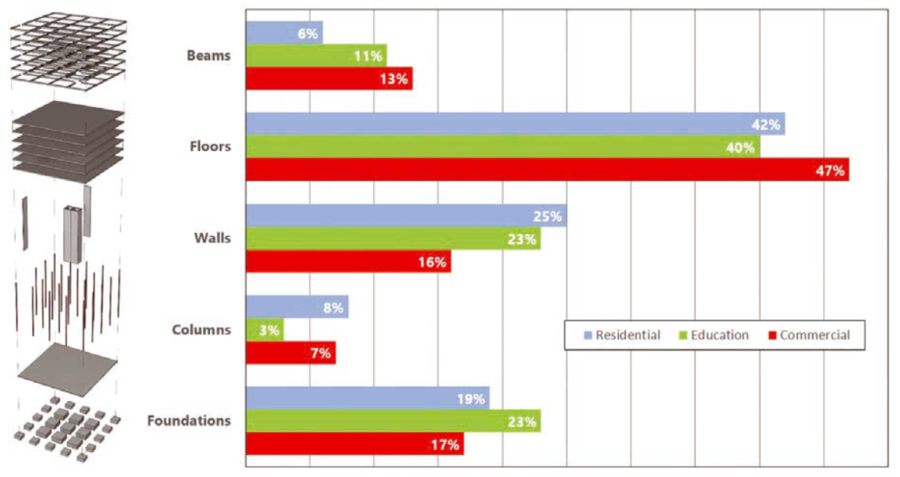
Figure 9 – Typical distribution of embodied carbon within structure

Through assessing the impacts of the multiple opportunities, we have prioritised design time and effort on the activities which provide the most significant carbon reductions.

  - Configuration
The configuration of the building (layout, geometry, grids) is likely to have the largest impact on the carbon footprint of any new structure, as this limits the potential best-case outcome and options available. The boxes below summarise the considerations made on this project into possible building configurations and the impacts of potential options in relation to carbon.

Objectives and Actions taken:

Next Steps and Opportunities:
  - Structural solutions
In addition to comparing configurations, a comparison of structural systems has also been made, considering material choices, manufacturing methods and construction techniques. The carbon impacts of key structural solutions have been assessed in this section, to provide a sustainability metric that can be used alongside considerations such as cost, programme and aesthetics to determine the most suitable approach for the project.
The options have been considered holistically to understand the trade-offs of certain solutions, e.g. the lowest carbon superstructure solution may not lead to the lowest carbon substructure solution, so both must be considered together to understand the lowest carbon total solution.
The boxes below summarise the carbon impacts of the proposed structural solutions for the scheme.

Objectives and Actions taken:

Next Steps and Opportunities:
  - Design criteria
The design criteria (e.g. load-carrying capacity, movement requirements etc.) used for the structural design directly impacts the amount of material required and therefore the carbon emissions, for all configurations and options.
Whilst design criteria are often stipulated or recommended from codes and standards, there is also a significant amount of interpretation required. Through considering realistic connotations of design assumptions and requirements, the design criteria may be more accurately defined which in turn may unlock carbon savings.
The sections below therefore summarise the key considerations relating to accurately defining criteria, and the design approaches taken to making these criteria as carbon-efficient as possible.
    - Strength (loading requirements)
The strength of the structural components (slabs, beams, frames etc,) are governed by the load that they must carry or resist.
The loads used in the design must be accurate and representative of the building contents and expected occupancy. Loads used in the design, both for permanent and imposed actions, have historically been overly-conservative for several reasons (e.g. perceived risk, provision of flexibility for change of use, lack of measurements used to inform revisions). Whilst acceptable in the past, conservative approaches have resulted in wasteful use of resources, and unnecessary emissions. Such approaches are therefore not justifiable in the climate emergency.
The boxes below highlight the considerations taken to loading requirements and the carbon impacts of any loading requirements specified in the brief which are above those specified in the design codes. A narrative is provided outlining steps such as requirements to improve the accuracy of permanent loads that inform the design.

Objectives and Actions taken:

Next Steps and Opportunities:

    - Serviceability
The serviceability of the structural components is set by agreeing how much those components can move, bend, vibrate, or crack. Exceeding agreed serviceability limits does not pose a safety risk to the building occupants, but may lead to discomfort or concern.
The size of structural components sometimes needs to be increased beyond the minimum material required to meet the strength criteria (Section 4.3.1) – meaning that material and carbon is wasted. Often this is due to a poor structural configuration (e.g. spans that are inefficiently long, or beam depths forced to be too shallow, refer Section 4.1), but there are often opportunities to reduce carbon through interrogating the serviceability requirements more closely.
As with loading, guidance for serviceability requirements is often provided in codes and standards, but a thorough understanding and investigation of requirements aids carbon saving.
The boxes below outline the actions taken to interrogate serviceability requirements to achieve carbon savings whilst meeting the requirements of the systems and occupants. Requirements for procurement and further discussions required with suppliers are also provided to ensure the design assumptions are fulfilled at Construction without issue.

Objectives and Actions taken:

Next Steps and Opportunities:
  - Optimisation of sizes
There is a considerable opportunity to reduce carbon through the optimisation of structural element sizes, as individual elements can each be sized individually to accurately meet their strength and serviceability criteria. Failing to optimise the final design means using material that isn’t needed to meet design requirements, resulting in unnecessary carbon emissions.
Whilst the term ‘optimisation’ can indicate the use of automated computer software to find the optimal design, it can also refer to undertaking the process manually.
There are several barriers to optimisation, including design time, perceived risk and programme impacts, as well as outdated traditional reasons such as calculation and modelling time, and lack of technology for construction operations. However, using current technology to overcome many barriers, optimisation can also deliver benefits beyond carbon savings, with lower material usage reducing material costs.
Efforts made to optimise the structural design so far are outlined below, with utilisations indicated to demonstrate how optimised the solution is. Opportunities that have been identified to overcome barriers to any further optimisation are also presented.

Objectives and Actions taken:

Next Steps and Opportunities:
  - Supporting other disciplines
Whilst this report generally focuses on the structural design approaches, the overall goal remains for the lowest carbon whole-building solution to be achieved – i.e. the lowest possible total of all carbon emissions across all design disciplines involved in the project.
Close collaboration between design disciplines enables cross-discipline savings, and enables the team to check that a carbon saving in one discipline doesn’t lead to a larger carbon increase in another.
In addition to the carbon savings and processes outlined in this chapter, there are several areas in which carbon has been reduced by other design disciplines across non-structural building elements. A summary of these is provided below.

Objectives and Actions taken:

- Construction approach
Appointing the contractor provides a valuable opportunity to review the design with fresh eyes and search for opportunities to further reduce the carbon emissions of the design (e.g. through more efficient construction technologies, aligning material grades with construction sequencing, or considering offsite methods of manufacture where it presents a carbon saving).
Close collaboration is required between contractor and designer to ensure that carbon emissions do not increase in response to other construction drives (e.g. changing the material specification or using more material in the hope of it increasing construction speed), and early engagement with contractors can enable a more holistic approach to reducing carbon.
This section highlights measures taken by the design and construction team to ensure that low-carbon design aspirations are realised in the final constructed building.
  - Specification
There are many considerations that must be made to ensure materials are extracted and produced more sustainably – reducing impact on climate and biodiversity, and providing societal benefits where possible.
Transparency is key to understanding the sources and production methods used for materials, which is historically poor in the industry and an action that every project should look to address. This can be best achieved by mandating the provision of Environmental Product Declarations (EPD) for all main materials and products used on site – these EPD provide all the environmental impacts associated with the production process.
The specification has also been used to ensure the requirements of the materials assumed in the design can be achieved in low carbon ways. These approaches are outlined in the boxes below, with the outcomes included in the relevant project material specifications to ensure the design intent is achieved on the Construction site.

Objectives and Actions taken:

Next Steps and Opportunities:

  - Procurement
The requirement to consider carbon through the procurement process is important to unlock opportunities in the construction phase. The weighting of sustainability and carbon in tender responses provides a good mechanism for encouraging this, as does qualitative considerations including willingness to engage innovatively on previous projects and in research and development (R&D) initiatives.
Recommendations for opportunities to engage the contractor and supply chain to reduce carbon are provided below in relation to this project.
Further, through sharing this report with the contractor, it is hoped that the report can be used to inform and enable low carbon outcomes. Finally, procurement must be used to ensure the supply chain is committed to achieving net zero, through supporting industry initiatives, and monitoring the carbon associated with their activities through requesting EPDs and recording transport, waste and site emissions.

Objectives and Actions taken:

Next Steps and Opportunities:
  - Enabling in-use and end-of-life benefits
The whole life-cycle of the building has been considered throughout the structural design to develop a solution that will be low carbon throughout its life. Many considerations have been made to how the building can adapt to changes of use, as well as being a useful asset at end of life feeding into the circular economy. It is important that these considerations and ambitions are achieved in the construction and building operation.
Where reused elements or materials have been considered in the design, early engagement with the contractor, building insurers and Building Control will ensure that testing and detailing has been discussed early enough to ensure that the feasibility of this is not lost when the project reaches site.
The boxes below therefore summarise the key information and requirements related to these decisions for the construction and in-use stages, to ensure the design intention is achieved.

Objectives and Actions taken:

Next Steps and Opportunities:

https://www.un.org/en/
https://www.unep.org/resources/report/2021-global-status-report-buildings-and-construction
Refer to: https://builtenvironmentdeclares.com/
https://www.istructe.org/resources/guidance/design-for-zero/
https://www.leti.london/ecp
This definition is based on the definition at https://www.istructe.org/journal/volumes/volume-99-(2021)/issue-6/climate-jargon-buster/, but with the additional requirement to meet local carbon targets, in alignment with the definition agreed by the broader built environment industry in the UK.
https://www.istructe.org/journal/volumes/volume-99-(2021)/issue-7/a-short-guide-to-carbon-offsetting/
https://www.ipcc.ch/sr15/
https://www.istructe.org/resources/blog/the-hierarchy-of-net-zero-design/
https://www.leti.london/circulareconomy1pager
https://www.istructe.org/resources/guidance/how-to-calculate-embodied-carbon/
https://www.meicon.net/
https://www.istructe.org/journal/volumes/volume-98-(2020)/issue-8/lean-design-10-things-to-do-now/

